Test Case: tc006_SPX_Dev5_Crear_Requisicion_Spot_Tipo_Cobro_Proyect_Urgent
Step 1 - Enter username and password and click to button Enter: Credentials Entered
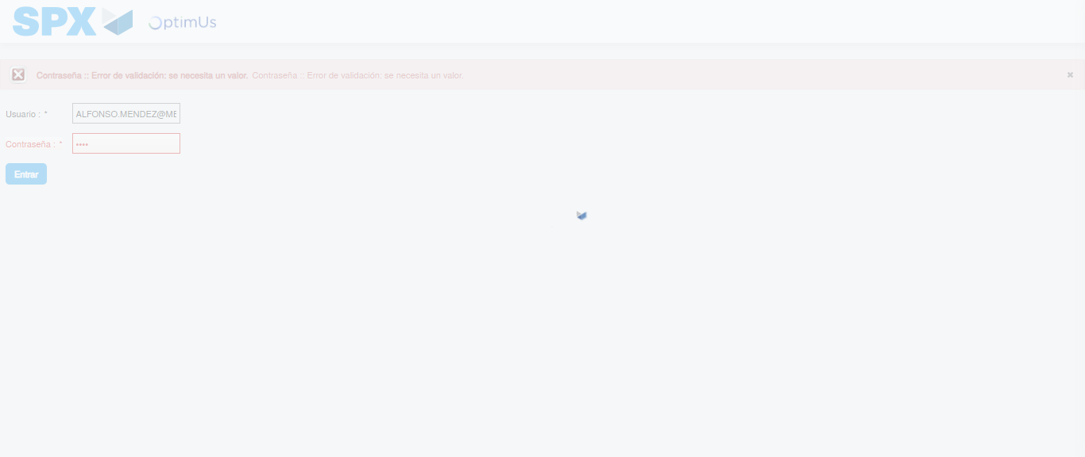Image file-name: QC_Testing-tc006_SPX_Dev5_Crear_Requisicion_Spot_Tipo_Cobro_Proyect_Urgent-1783379542892

Step 2 - Select to UEN and Access to Spot Buy Requisitions : UEN Correctly selected and Correct access
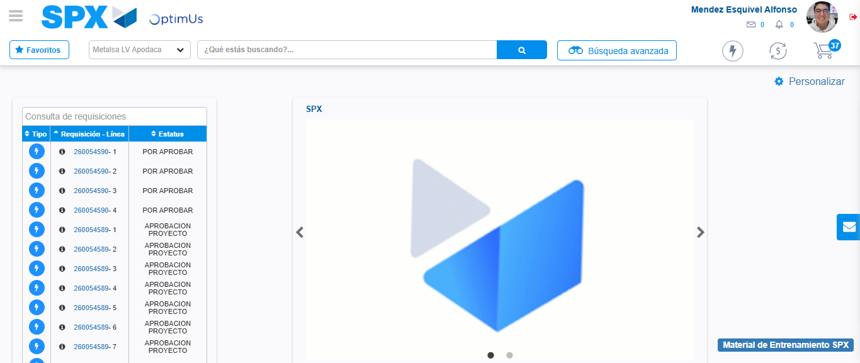Image file-name: QC_Testing-tc006_SPX_Dev5_Crear_Requisicion_Spot_Tipo_Cobro_Proyect_Urgent-1783379567893

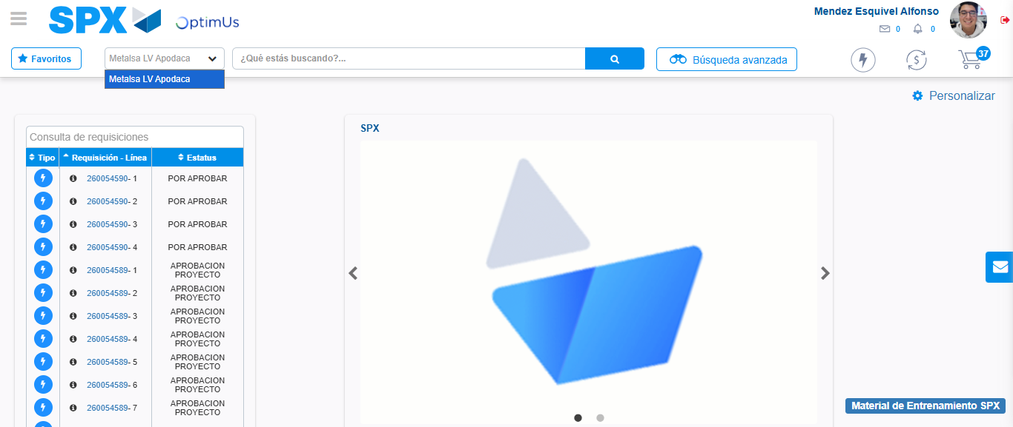Image file-name: QC_Testing-tc006_SPX_Dev5_Crear_Requisicion_Spot_Tipo_Cobro_Proyect_Urgent-1783379570372

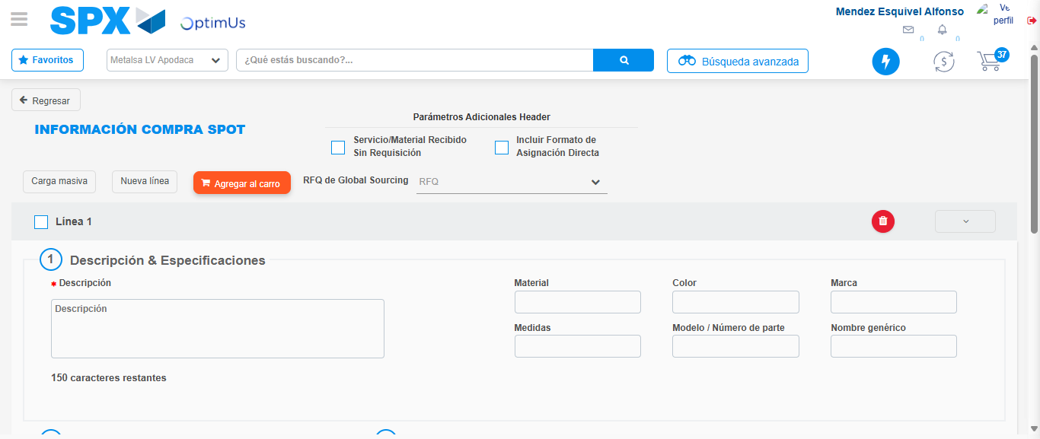Image file-name: QC_Testing-tc006_SPX_Dev5_Crear_Requisicion_Spot_Tipo_Cobro_Proyect_Urgent-1783379592046

Step 3 - Data Capture Spot Buy Requisition: Data captured correctly
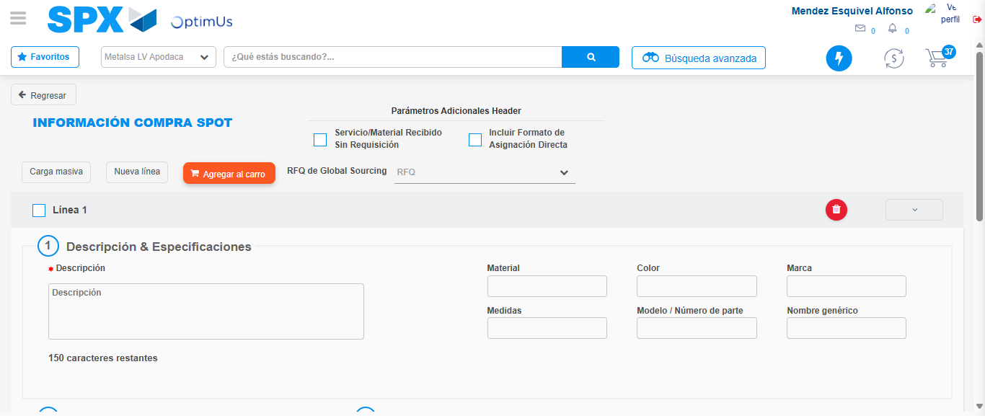Image file-name: QC_Testing-tc006_SPX_Dev5_Crear_Requisicion_Spot_Tipo_Cobro_Proyect_Urgent-1783379592338

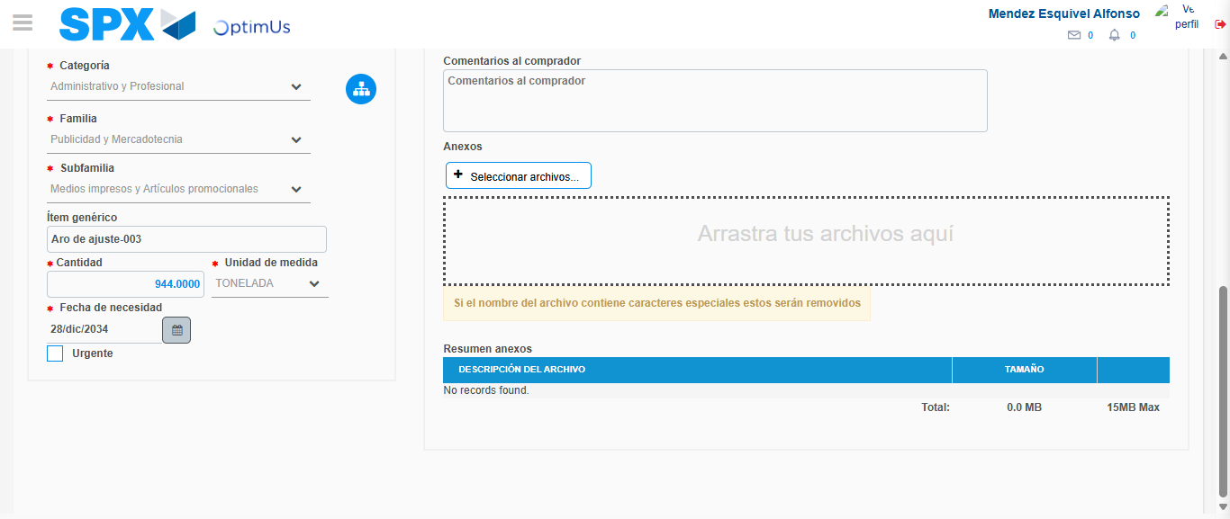Image file-name: QC_Testing-tc006_SPX_Dev5_Crear_Requisicion_Spot_Tipo_Cobro_Proyect_Urgent-1783379602340

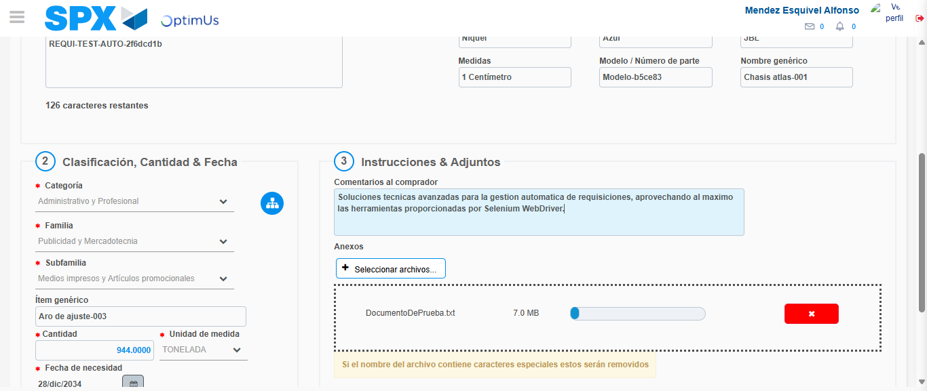Image file-name: QC_Testing-tc006_SPX_Dev5_Crear_Requisicion_Spot_Tipo_Cobro_Proyect_Urgent-1783379603042

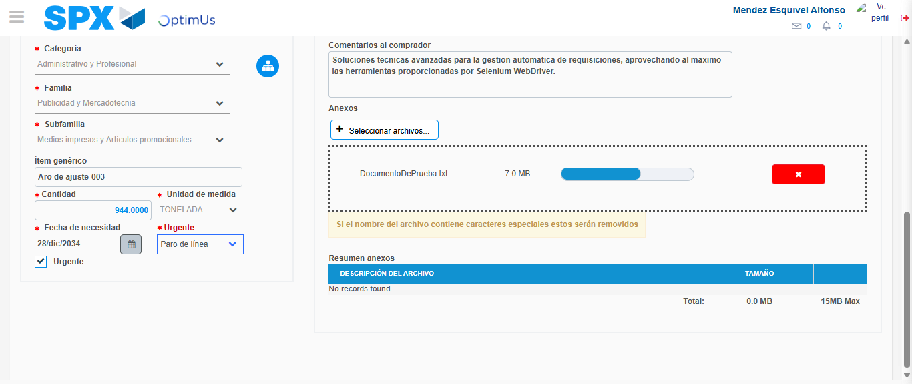Image file-name: QC_Testing-tc006_SPX_Dev5_Crear_Requisicion_Spot_Tipo_Cobro_Proyect_Urgent-1783379606615

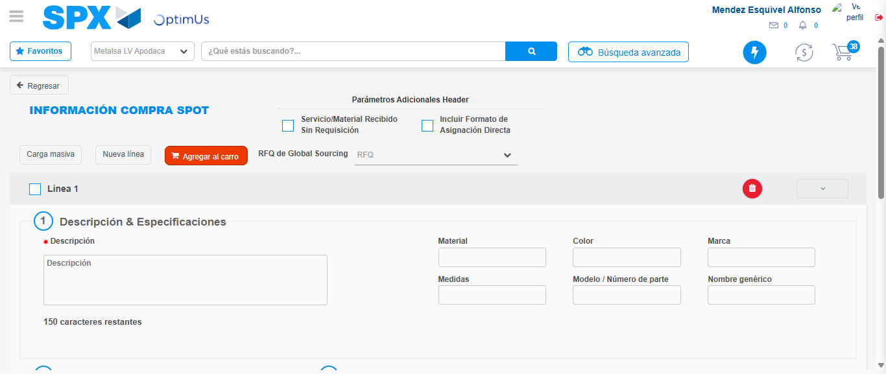Image file-name: QC_Testing-tc006_SPX_Dev5_Crear_Requisicion_Spot_Tipo_Cobro_Proyect_Urgent-1783379614715

Step 7 - Return to Main Page SPX : Return to Main Page SPX
Image file-name: QC_Testing-tc006_SPX_Dev5_Crear_Requisicion_Spot_Tipo_Cobro_Proyect_Urgent-1783379567893

Image file-name: QC_Testing-tc006_SPX_Dev5_Crear_Requisicion_Spot_Tipo_Cobro_Proyect_Urgent-1783379570372

Image file-name: QC_Testing-tc006_SPX_Dev5_Crear_Requisicion_Spot_Tipo_Cobro_Proyect_Urgent-1783379592046

Image file-name: QC_Testing-tc006_SPX_Dev5_Crear_Requisicion_Spot_Tipo_Cobro_Proyect_Urgent-1783379616930

Image file-name: QC_Testing-tc006_SPX_Dev5_Crear_Requisicion_Spot_Tipo_Cobro_Proyect_Urgent-1783379617116

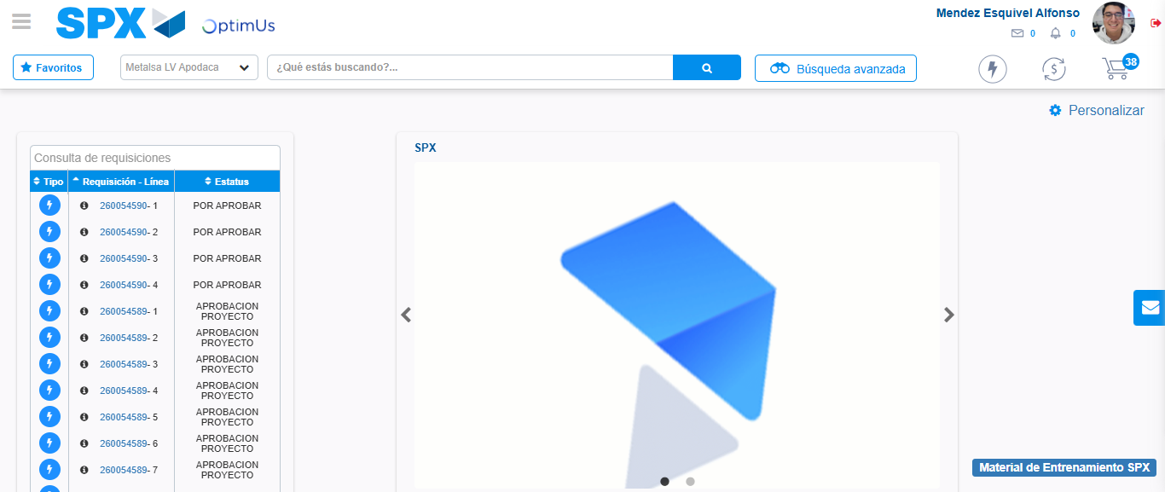Image file-name: QC_Testing-tc006_SPX_Dev5_Crear_Requisicion_Spot_Tipo_Cobro_Proyect_Urgent-1783379638319

Step 8 - Log Out : Log Out SPX
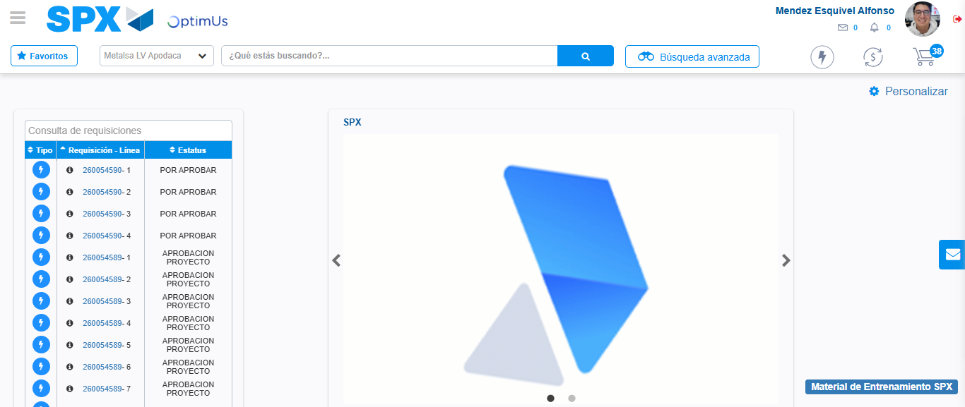Image file-name: QC_Testing-tc006_SPX_Dev5_Crear_Requisicion_Spot_Tipo_Cobro_Proyect_Urgent-1783379638518

